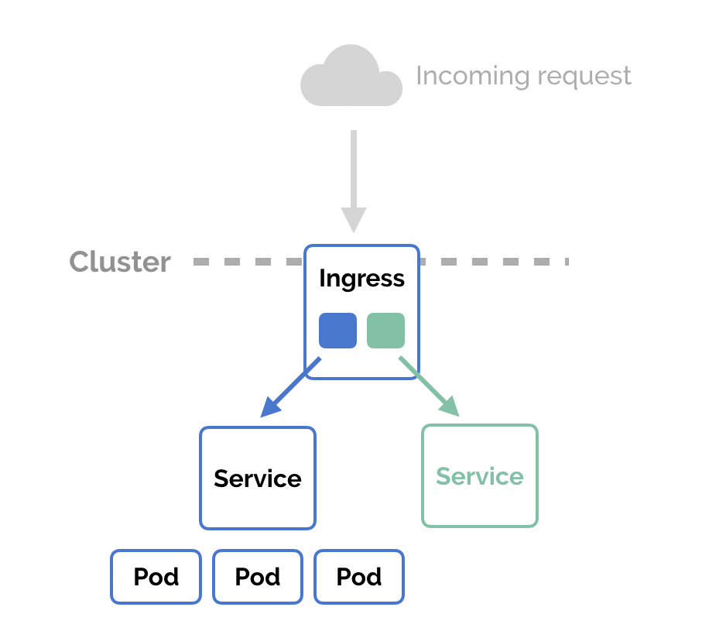

**SSH to your AWS Workstation**

**ssh devops@<public-ip-addr**> of your Workstation  
Password is : **Dev0p$!!/**

**Replace <your-name> with your name throughout the lab.**

**Create three Deployments by running the below commands.**

**1. Deployment 1**

|  |
| --- |
| $ mkdir /home/devops/ingress  $ cd /home/devops/ingress  $ kubectl run -n <your-name> <your-name>-1 --image=lovescloud/nginxdemo:v1 --port=80 |



**2. Deployment 2**

|  |
| --- |
| # kubectl run -n <your-name> <your-name>-2 --image=lovescloud/nginxdemo:v2 --port=80 |



**3. Deployment 3 - The default Backend echo server**

|  |
| --- |
| # kubectl run -n <your-name> <your-name>-echoserver --image=gcr.io/google_containers/echoserver:1.4 --port=8080 |



**4. Check if your deployments are running**

|  |
| --- |
| # kubectl get deploy -n <your-name> |

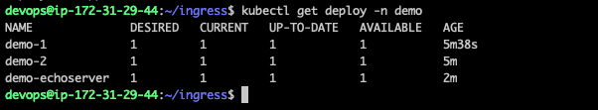

**5. Expose your deployments over NodePort**

**Deployment 1**

|  |
| --- |
| $ kubectl -n <your-name> expose deployment <your-name>-1 --target-port=80 --type=NodePort |

**Deployment 2**

|  |
| --- |
| # kubectl -n <your-name> expose deployment <your-name>-2 --target-port=80 --type=NodePort |

**Deployment 3**

|  |
| --- |
| # kubectl -n <your-name> expose deployment <your-name>-echoserver --target-port=8080 --type=NodePort |



**6. Check the Services**

|  |
| --- |
| # kubectl get svc -n <your-name> |

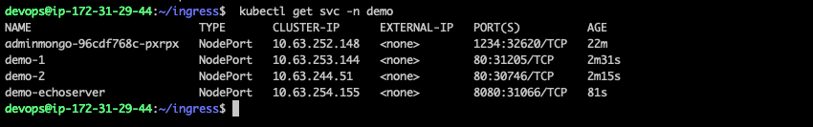

**7. Deploy the Ingress resource.**

|  |
| --- |
| $ curl -k https://pastebin.com/raw/ckUZHEhi > ingress.yaml |
|  |

**8. Now, edit the yaml file and update the below fields.**

|  |
| --- |
| $ vim ingress.yaml |

**<your-name>** update your name with your name

**<your-service1-name>** with your service name for the first deployment (check step 6)

**<your-service2-name>** with your service name for the second deployment (check step 6)

**<path1>** - Example albert-demo-1

**<path1>** - Example albert-demo-2

To save and exit once the changes have been made

**Press Ecs :wq and hit enter to save and exit.**

Example of the deployment ingress.yaml file

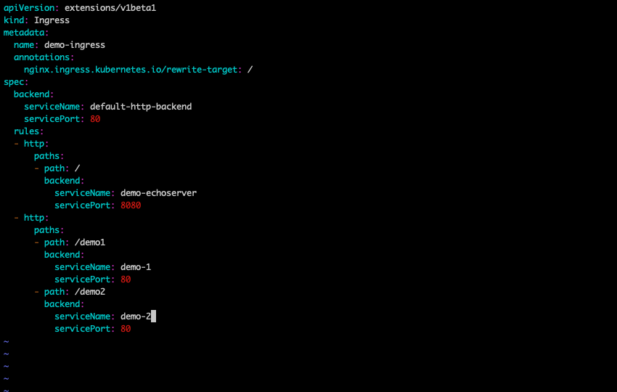

**9. Deploy the Ingress.**

|  |
| --- |
| $ kubectl create -f ingress.yaml -n <your-name> |



**10. Check the Deployment**

|  |
| --- |
| # kubectl get ing -n <your-name> |

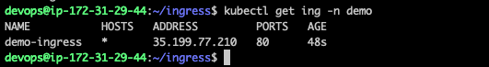

**11. Describe the Ingress**

|  |
| --- |
| $ kubectl describe ing <your-name>-ingress -n <your-name> |

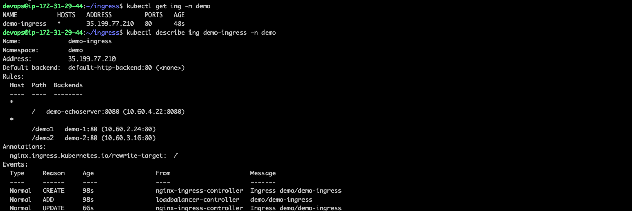

**12. Accessing the Deployments over Ingress.**

|  |
| --- |
| $ kubectl get ing -n <your-name> |

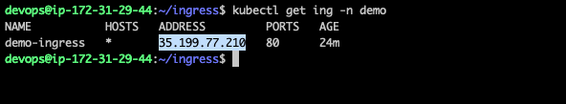

**Copy the ADDRESS to access the Ingress.**

**Access the Ingress from the ADDRESS provided.**

**Example**

[**http://35.199.77.210**](http://35.199.77.210)

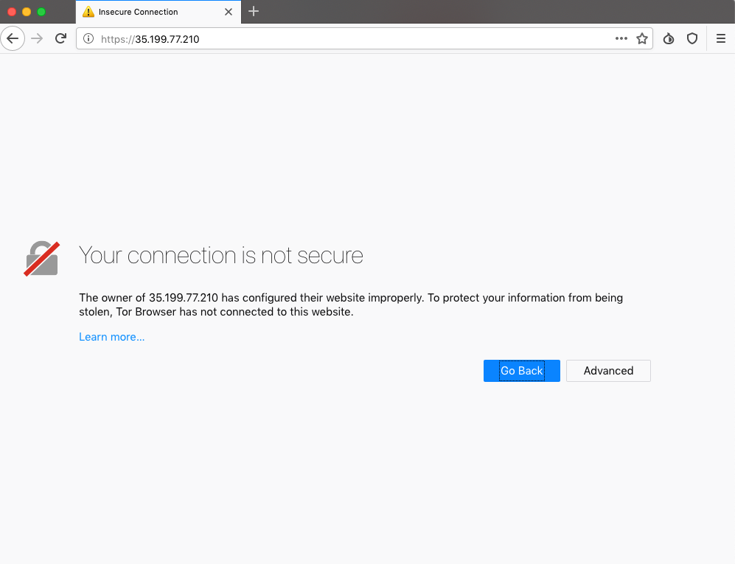

**Click on the Advanced button and click on Proceed to (unsafe) and click on Add exception to Proceed.**

**16. The default backend i.e the echoserver**The url above will redirect the user to the default backend as we defined in our ingress deployment. The default backend for this demo is the echo server.

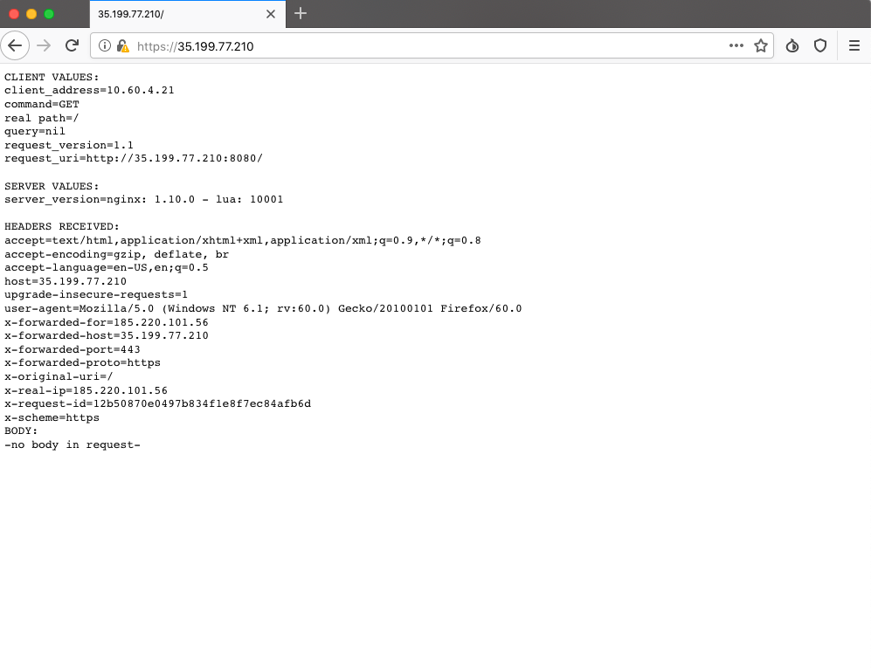

17. Now try to access the ingress controller through the **/paths** you specified in the **ingress.yaml**

**https://<worker-node-public-ip>:NodePort/path1**

Example

[**https://35.199.77.210/demo1**](https://35.200.167.44:31196/path1)

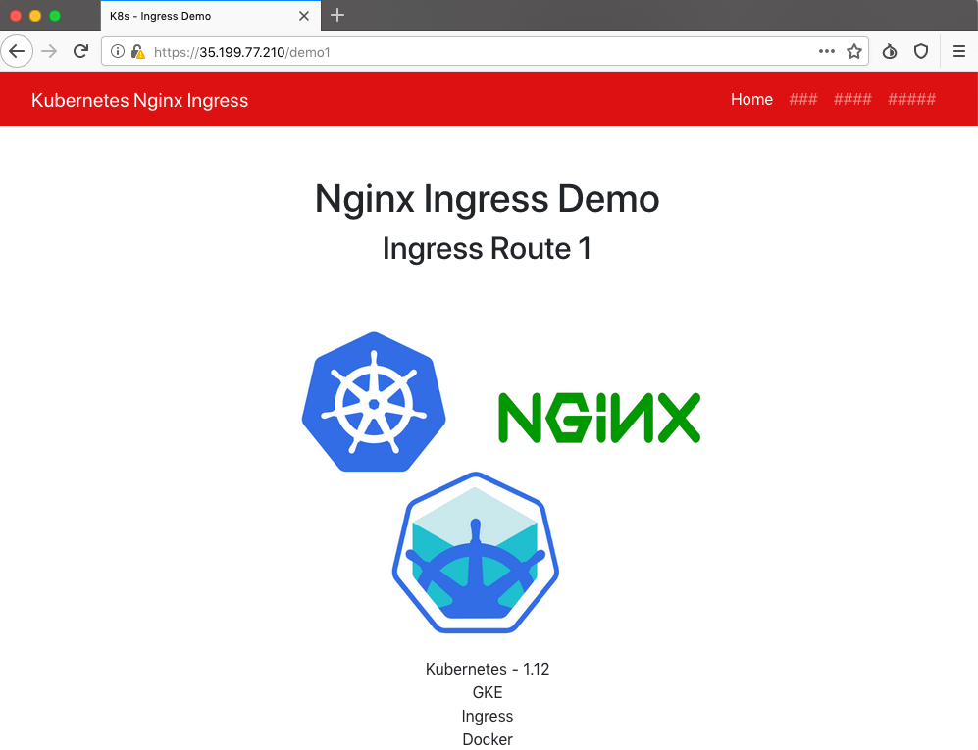

https://<worker-node-public-ip>:NodePort/path2

Example

[**https://35.199.77.210/demo2**](https://35.200.167.44:31196/path1)

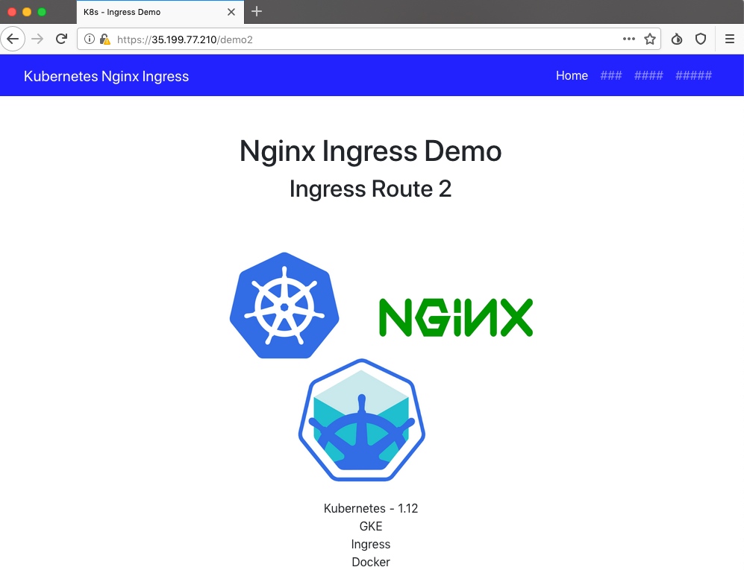

18. Cleaning Up

Delete the deployments and services before moving on to the next labs in order to

reduce the cluster load.

|  |
| --- |
| $ kubectl get deployment -n <your-name> $ kubectl delete deployment arg1 arg2 arg3 ..argN -n <your-name> |

Where arg1 arg2 arg3 are deployment names

And to delete the service we created

|  |
| --- |
| $ kubectl get svc -n <your-name> $ kubectl delete svc arg1 arg2 arg3 ..argN -n <your-name> |

Where arg1 arg2 arg3 are service names